I am going to make a power bank using old laptop battery and a power bank PCB (Printed Circuit Board) IC.

**PROCEDURE**

Take a old laptop battery and open it. You can find either 6 or 4 Li-ion cells in it with PCB used for charging laptop batteries. 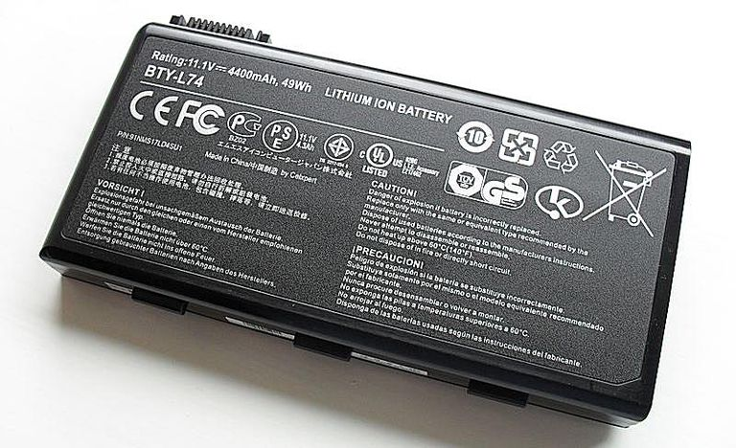

The power bank PCB IC I used is

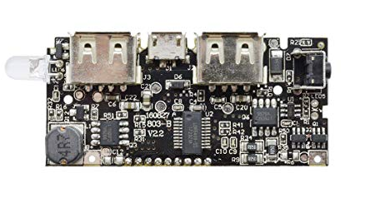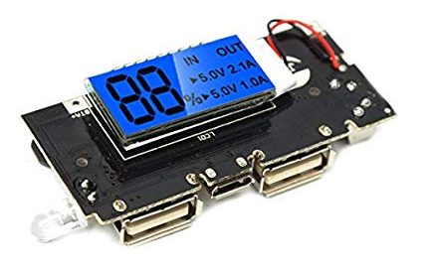

Now make the connections as shown in the fig.

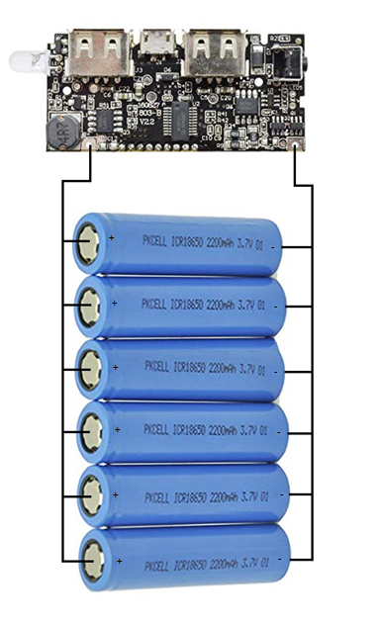

Power bank is ready. Charge it before use the very first time.